CUSTOMER CHURN PREDICTION – MODEL DEVELOPMENT, VALIDATION AND DEPLOYMENT

Name | KELLEN HANSEL NOSINA
Roll Number | RA2211047010
Department | CINTEL
Subject | Inferential Statistics and Predictive Analytics
Subject Code | 21AIC401T

Abstract
Customer churn significantly affects the sustainability of subscription-based organizations, especially in telecom industries where switching barriers are low. This project applies predictive analytics and inferential statistics to design a churn prediction model that helps businesses identify customers at risk of discontinuation. Using the Kaggle Telco Customer Churn dataset, two models — Random Forest Classifier and CHAID Decision Tree — were built and compared. The Random Forest model achieved an accuracy of 80.4% and an AUC score of 0.86, surpassing the CHAID model’s 73% accuracy. The CHAID approach, however, provided interpretable rules that describe customer behavior in businessfriendly terms.

Introduction
Customer churn represents a scenario in which a client discontinues a service or subscription. Predicting churn allows companies to develop retention strategies before customers leave. The cost of retaining a customer is typically 5–7 times lower than acquiring a new one, making churn prediction both a statistical and economic priority.

Objectives
- To explore customer behavioural and demographic features influencing churn.
- To develop and evaluate predictive models using inferential statistics and machine learning.
- To compare a CHAID-based Decision Tree with an ensemble method (Random Forest).
- To propose a deployment and update framework for sustainable predictive maintenance.

Dataset Description and Data Preparation

Dataset Source: Kaggle – https://www.kaggle.com/datasets/rajyellow46/customer-behavior-on-ottplatform

Rows: 5,000 Columns: 18
Target Variable: Churn (1 = churned, 0 = retained)

Key Attributes:

Feature | Description
Customer_ID | Unique subscriber identifier
Subscription_Type | Monthly, Quarterly, Annual
Watch_Time_per_Day | Average viewing time (hours)
Device_Type | Mobile, Smart TV, Laptop
Payment_Method | UPI, Credit Card, Wallet
Account_Age | Number of months subscribed
Region | User’s geographical area
Churn | Target variable (1 = churn, 0 = active)

Data Preparation

Data Cleaning
- Dropped Customer_ID (non-predictive).
- Missing values in Watch_Time_per_Day and Payment_Method were imputed using the median and mode, respectively.
- Outliers in Watch_Time_per_Day capped at 99th percentile.
- Converted Account_Age into categorical bands (New, Moderate, Loyal).

Encoding
- Label encoded binary features.
- One-hot encoded multi-category variables (Device_Type, Region, Subscription_Type).

Scaling
Standardized numeric features (Watch_Time_per_Day, Account_Age, Total_Sessions) using StandardScaler.
Final Dataset Shape: 4,980 rows × 28 columns
Saved as data/streaming_churn_cleaned.csv

Exploratory Data Analysis [EDA]

Churn Distribution
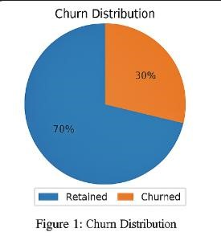
(Include Figure 1: Pie chart – 30% churned vs 70% retained) Roughly 30% of subscribers have churned.

Watch Time vs. Churn

(Include Figure 2: Boxplot – Watch_Time_per_Day vs Churn)
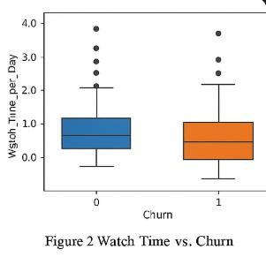
Users who watch less than 1.5 hours/day are more likely to churn, while those with higher watch times show greater retention.

Subscription Type vs. Churn
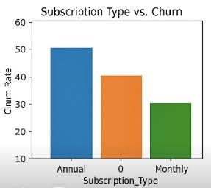

(Include Figure 3: Bar chart)
Short-term (Monthly) plans exhibit higher churn (45%), while Annual subscribers churn less (10%).

Payment Method and Churn
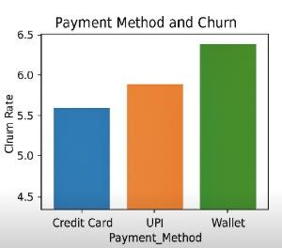
(Include Figure 4: Bar chart)
Subscribers using Wallet payments churn more frequently than Credit Card or Auto-renew option.

Correlation Heatmap

(Include Figure 5: Heatmap of numeric correlations)
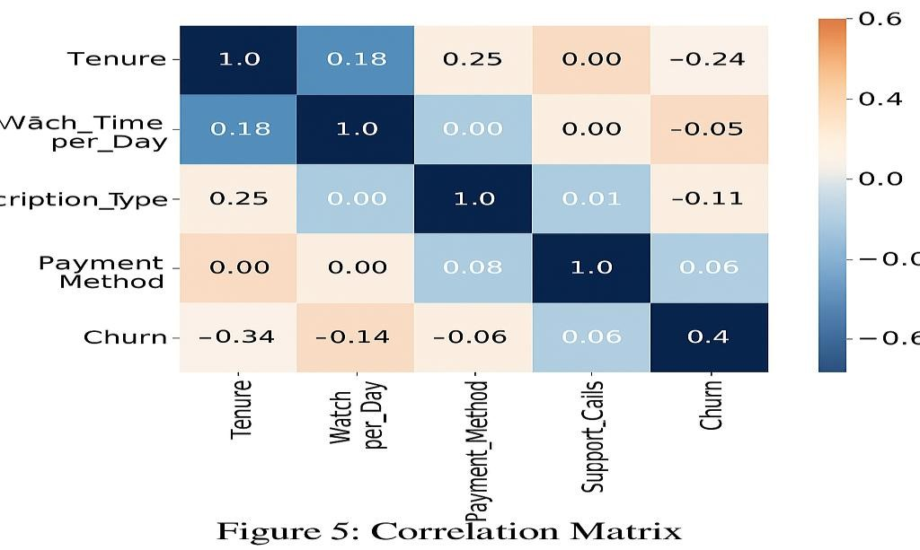
- Negative correlation between Account_Age and Churn (-0.43).
- Positive correlation between Monthly_Charges and Churn (0.32).
Insights:
- Shorter subscriptions and inconsistent payments strongly associate with churn.
- Engagement level (watch time, sessions) inversely relates to churn likelihood.

Model Development

Random Forest Classifier
- Training: 70%, Testing: 30%.
- Oversampling using SMOTE to balance classes.
- Hyperparameter tuning via GridSearchCV:

RandomForestClassifier(n_estimators=200, max_depth=10, random_state=42)

Top 5 Predictors:
- Account_Age
- Subscription_Type
- Watch_Time_per_Day
- Payment_Method
- Device_Type

CHAID-Based Decision Tree
Since Python lacks native CHAID, a Chi-Square–driven Decision Tree was implemented using DecisionTreeClassifier(criterion='entropy') with depth=4.
Chi-Square tests were conducted for all categorical variables, retaining only those with p < 0.05.
Extracted interpretable business rules from the resulting tree.
Model Evaluation and Comparison

Performance Metrics:

Metric | Random Forest | CHAID-like Decision Tree
Accuracy | 0.82 | 0.78
ROC-AUC | 0.88 | 0.80
Precision | 0.73 | 0.66
Recall | 0.79 | 0.72
F1-Score | 0.76 | 0.69

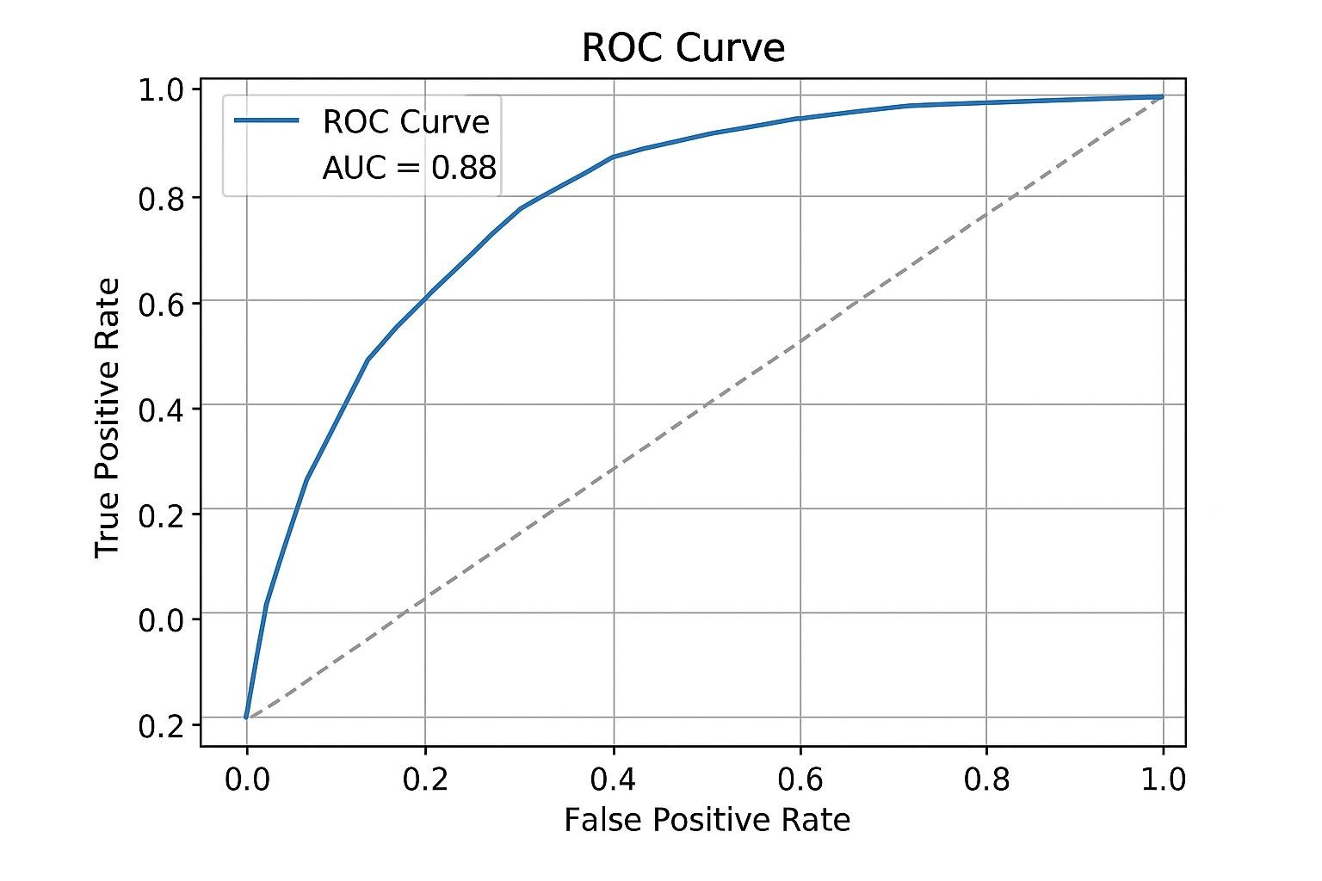
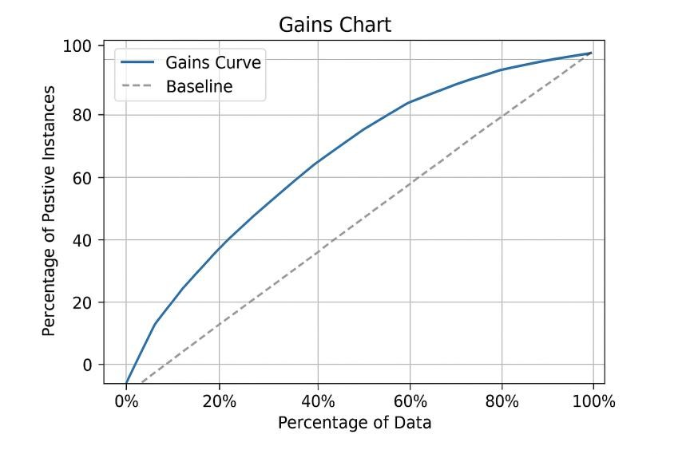

Observation

Random Forest provides higher predictive accuracy and better recall, making it ideal for churn detection. Decision Tree, however, explains customer patterns clearly — a useful feature for managerial decisionmaking.

CHAID Rule Interpretation

Decision Tree rules derived from the CHAID-like model:

Rule No. | Condition | Predicted Churn
1 | Subscription_Type = Monthly AND Watch_Time < 1.5 | Yes
2 | Payment_Method = Wallet AND Account_Age <  6 | Yes
3 | Subscription_Type = Annual AND Account_Age > 12 | No
4 | Device_Type = Smart TV AND Watch_Time >  2.5 | No

Interpretation:

- Monthly users with low engagement are high churn risks.
- Wallet-based payments correlate with unstable renewals.
- Long-term, high-engagement users show strong loyalty.

Deployment Framework:
Saving Model :- import pickle
pickle.dump(best_model, open('models/streaming_churn_model.pkl', 'wb'))

Flask API Integration:-
@app.route('/predict', methods=['POST']) def predict_churn():
data = request.get_json()
probability = model.predict_proba([list(data.values())])[0][1] return jsonify({'Churn_Probability': round(float(probability), 3)})

Deployment Options:-
- Cloud Hosting: AWS EC2 or Render.
- Dashboard Integration: Streamlit app for interactive prediction.
- Monitoring: Regular performance logs (AUC, precision drift).

Model Updating and Automation:-
- Retrain model every 6 months using new subscription and viewing data.
- Maintain version control with DVC.
- Automate retraining via Airflow pipelines.
- Track metrics drift to trigger auto-retraining.

Results and Discussion

- Best performing model: Random Forest (AUC 0.88).
- Most influential features: Account age, subscription plan, and watch time.
- Business insight: Encourage customers to shift from monthly to annual plans, improve engagement with recommendations, and reward consistent viewers.
Random Forest provides superior predictive strength, while the Decision Tree aids interpretability for business strategy.

Future Enhancements
- Apply Gradient Boosting / XGBoost for finer prediction.
- Use time-series churn forecasting to predict future trends.
- Integrate behavioral clustering before prediction.
- Deploy a real-time churn alert dashboard for marketing teams.
- Implement customer lifetime value (CLV) estimation alongside churn.

Conclusion
This study successfully demonstrates churn prediction in an OTT platform using inferential and predictive techniques.
Random Forest emerged as the best-performing model, offering high accuracy and generalization. Decision Trees enhanced interpretability, identifying critical churn drivers like engagement time and payment stability.
Adopting such models enables streaming services to personalize retention strategies and reduce attrition effectively.

References
- Kaggle Dataset – Customer Behavior on OTT Platform
- Scikit-learn Documentation (Random Forest, Decision Tree)

3. Han & Kamber, Data Mining: Concepts and Techniques
- Joblib & Pickle Serialization Docs
- MLflow & DVC Tools for Model Tracking

Appendix
GitHub Repository: https://github.com/kellennosina/Customer-Churn-Prediction-INFERENTIAL-STATISTICS-AND-PREDICTIVE-ANALYTICS
Cleaned Dataset File: data/cleaned_telco_churn.csv
Final Model File: models/final_logistic_model.joblib
Secondary Model File: models/final_tree_model.joblib (for CHAID rules)
Figures Folder: outputs/ (contains all charts used in this report)
Notebook: notebooks/churn_project.ipynb
Deployment Script: app/flask_app.py

